“I’ve voted for the same party all my life, and really, I am no better off. Now I will change how I vote and give others a chance”

I llll

‘We can make a start in Torfaen by electing outside of the so-called maim parties who have let us down continually. You have the vote, that means you have the power’

Statement:

Due to the abject performance of both local and national politicians, we have decided to resurrect the name of PEOPLES VOICE.

We will be putting up candidates for the 2022 Local Elections in Torfaen, our candidates will have policies that represent Libertarian values.A libertarian is committed to the principle that liberty is the most important political value. Liberty means being free to make your own choices about your own life, that what you do with your body, and your property, ought to be up to you. Other people must not forcibly interfere with your liberty, and you must not forcibly interfere with theirs.

A political philosophy that advocates only minimal state intervention in the free market and the private lives of citizens.

Labour, Conservative and the illiberal party have interfered in families to the extent that it has in too many cases destroyed family life, the life that was once the ‘bedrock’ of civil society.

*libertas*, "freedom") is a [political philosophy](https://en.wikipedia.org/wiki/Political_philosophy) and [movement](https://en.wikipedia.org/wiki/Political_movement) that upholds [liberty](https://en.wikipedia.org/wiki/Liberty) as a core principle. Libertarians seek to maximize [autonomy](https://en.wikipedia.org/wiki/Autonomy) and [political freedom](https://en.wikipedia.org/wiki/Political_freedom), emphasizing [free association](https://en.wikipedia.org/wiki/Free_association_(Marxism_and_anarchism)), [freedom of choice](https://en.wikipedia.org/wiki/Freedom_of_choice), [individualism](https://en.wikipedia.org/wiki/Individualism) free speech and [voluntary association](https://en.wikipedia.org/wiki/Voluntary_association).

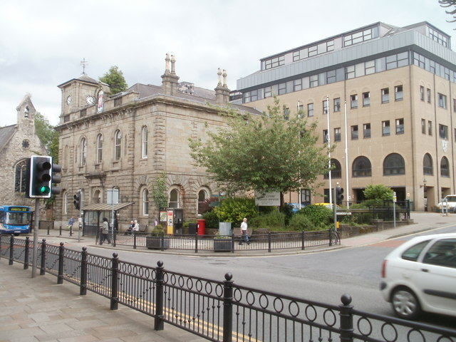

**Peoples Voice returns to the streets of Wales**

‘For too long we have allowed Labour to take us on a race to the bottom…this is now the poorest country in the UK’

**PEOPLES**

**VOICE**